Week 9:

I computed 3 sets of histograms based on the Mel Frequency Cepstral Coefficients. Here is the first set of Histograms, for ‘Driving Home’ by Dee Yan-Kee:

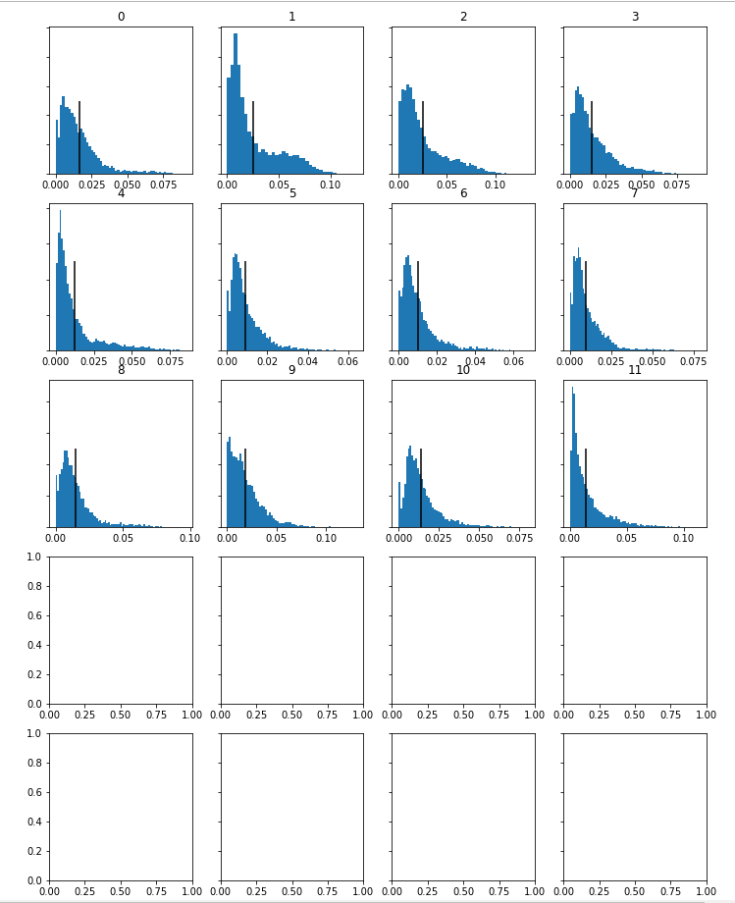

As you can see the last 8 histograms would not display and due to time constraints I was not able to provide a solution to this. However, we can see from the other histograms that they are all skewed to the left and all have one defined peak.

Here are the computed histograms for KieLoBot – Frogs and Stoned Funghi:

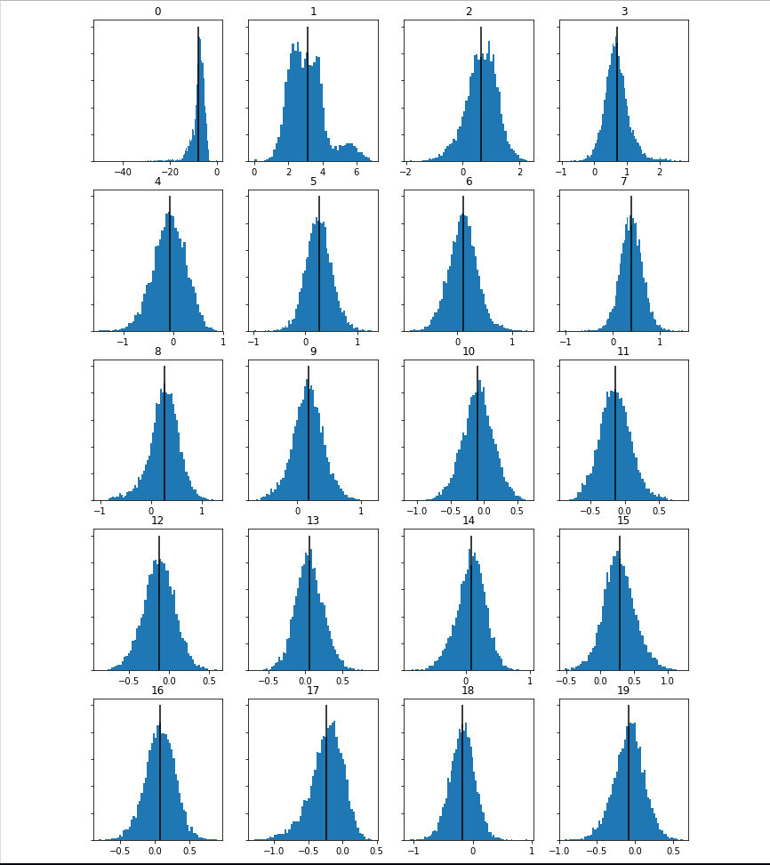

These Histograms have a much more centred peak and are taller overall than those of Dee Yan-Kee.

Here are the final computed histograms, from Scott Holmes’ Driven to Success:

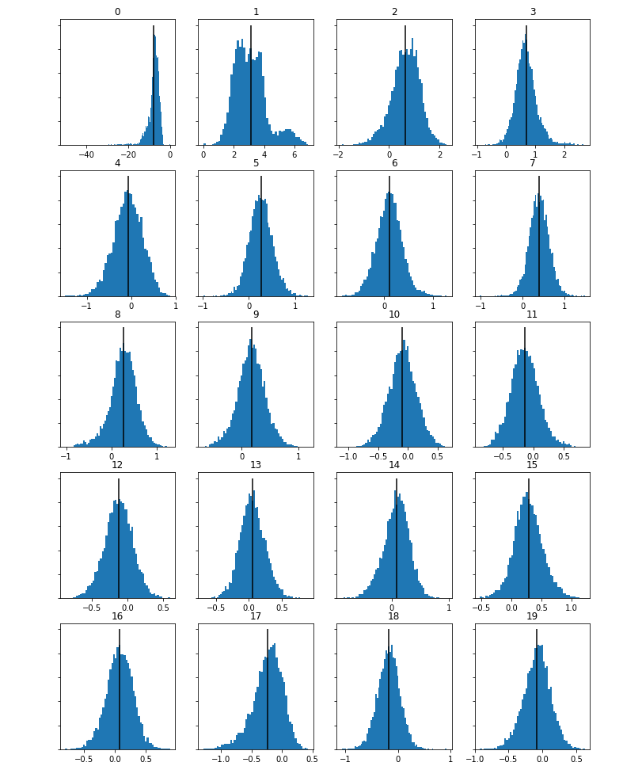

The latter of these histograms is very similar to those of KieLoBot however the first three are slightly different with the first being skewed to the right and the second appearing to have two defined peaks.

We can certainly see that these three tracks are of different genre and style by looking at these histograms.